Name: Kinzang Wangchuk

Student Id: 12190062

**Table OF Contents**

|  |  |  |
| --- | --- | --- |
| **Sl.No** | **Topics** | **Page Number** |
| **1** | **words** | **1-2** |
| **2** | **Visual Representation** | **2-3** |
| **3** | **Physical Objects Or Space** | **3-4** |
| **4** | **Time** | **4** |
| **5** | **Behavior** | **4** |
| **6** | **Consistent Design** | **5** |
| **7** | **Functionality** | **5** |
| **8** | **Cognition** | **6** |
| **9** | **Engagement** | **6** |
| **10** | **User Control** | **6** |
| **11** | **References** | **7** |

**Question 1 – You are required to present a solution after identifying five dimensions of interaction design and principles on a chosen website.**

**Five dimensions of interaction design**

**1.** **Words**

Words are sounds or representations in writing or printing that represent and communicate. The words on the website are intended to provide immediate clarity, inspiring readers to delve deeper. The words in the following figure do not have a clear meaning, so the web designer used a different font size that was inappropriate for that website.



Figure 1

Although not all users are from the same country, if the website is in an international language, it will benefit students from all over the world. In Figure 2, the designer used their own language, which affected other students and rendered them meaningless until they learned that specific language. The font size of the words is inconsistent.

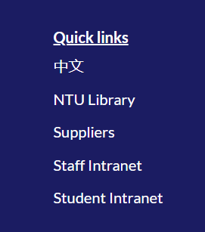

Figure 2

**2.** **Visual Representation**

It assists users in comprehending quantitative data by employing visual elements such as colors, graphs, and charts. Visual information is easier for our brains to process than words. Visualizing data on a website allows users to notice patterns that are difficult to recognize numerically. Color combinations on the current website did not meet user expectations.

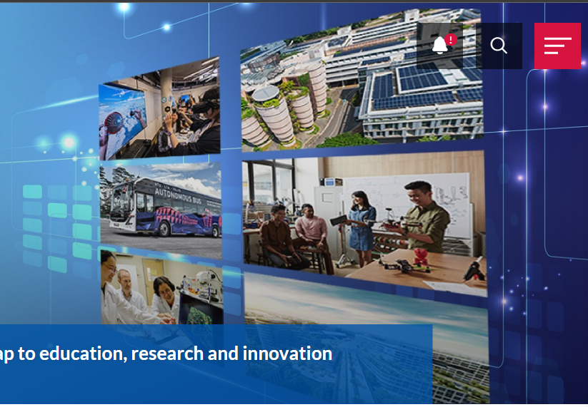

Figure 3

The background image in the preceding figure is not well aligned, and the user would prefer a well-aligned background image. Figure 3's navigation bar has a toggle section, but it makes no sense. There are many other sections and texts in the Toggle section that require a separate navigation bar.

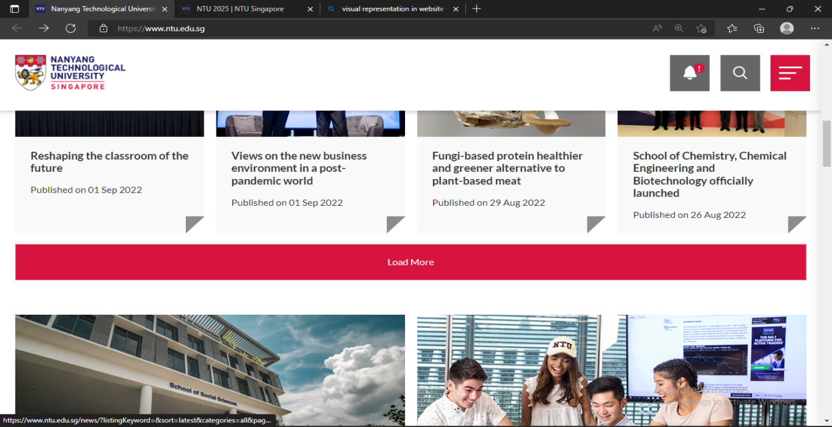

Figure 4

They have used unnecessary space in the above figure for the LoadMore button, which is not visible to the users.

**3.** **Physical Objects Or Space**

Users interact with the product or services through physical objects or space. For example, a phone with a finger and a computer with a mouse. This website is well-designed and responsive when viewed on a phone or a laptop. However, unnecessary space has been used in the website, making it suitable for the users.

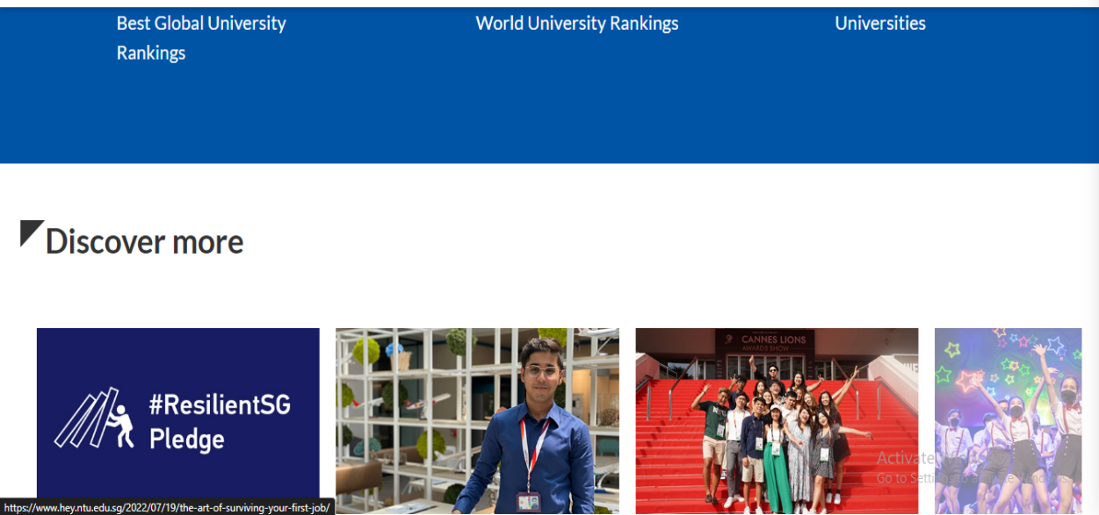

Figure 5

**4.** **Time**

Time is another factor that attracts users. Time dictates what we do and where we go. Time is associated with media that changes over time. Animations, sounds, and videos are examples. Another excellent use of time is the progress bar animation, which shows the progress of a specific process/operation. The time taken by the button or navigation was well planned, and it works as expected by the user.

**5.** **Behavior**

It is concerned with the interaction of the previous four dimensions with the products or services. On a website, how users can perform actions, reactions, and presentations. Create a user-friendly, adaptable, and understandable behavior.

**Interaction Design Principles**

**A)** **Consistent Design**

Making sure that elements in the user interface are consistent is what consistency in UI design is all about. They will have the same appearance and behavior. The logo on this website remains consistent even when we navigate to different pages. The font size on this website is not consistent. Different font sizes have been used, which is unappealing to the user and inconsistent.



Figure 6

B) **Functionality**

Users should find it as simple as possible. Functionality refers to how a design works to help users achieve their goals and needs. Users can navigate your site, find the information they need, and buy the product they want. We need a simple login form on this website so that we can access it via email.

**C)** **Cognition**

Cognition refers to what happens in the human mind while performing daily tasks. It involves many cognitive processes, such as thinking, remembering, learning, and making decisions. As a result, nothing on the current website creates tension for users.

**D)** **Engagement**

We stay connected to our users' interests, motivations, and goals through engagement. Take any action, such as subscribing or purchasing goods or services. Live chat support is required, as is a focus on product experience and the creation of interactive and engaging content.

**E)** **User Control**

User control are the building blocks of any software interface. Designers we must give the user the ability to exit unwanted actions easily. If we missed providing the user the control and freedom over the things they are using, they will abandon our product.

**References**

Instructor, I. D. F. C. (n.d.). *The five languages or dimensions of interaction design*. The Interaction Design Foundation. Retrieved September 9, 2022, from <https://www.interaction-design.org/literature/article/the-five-languages-or-dimensions-of-interaction-design>

Google. (n.d.). Google search. Retrieved September 9, 2022, from <https://www.google.com/search>

Google. (n.d.). Google search. Retrieved September 9, 2022, from <https://www.google.com/search?>